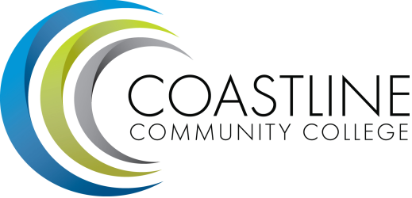
Accreditation Chairs Meeting Agenda
3/16/17
1:00 pm - 3:00 pm
College Center 4th Floor Conference Room

Committee Mandate: To oversee the production of the Institutional Self-Evaluation Report due to ACCJC in December 2018.

- CALL TO ORDER
  - Roll Call
  - Welcome
  - Adoption of Agenda
  - Review of meeting minutes from 2/24 Chairs meeting

- SPECIAL REPORTS & UPDATES
  - Team structure (A. Zentner / V. Rodriguez)
  - Review of timeline (D. Pittaway)
  - Protocol for committees to promptly post and keep meeting documents/reports organized online for easy access (D. Pittaway)

- ACTION ITEMS
  - Committee mandate (D. Pittaway)
  - Timeline (D. Pittaway)

- STANDING REPORTS
  - Standard I (chairs)
  - Standard II (chairs)
  - Standard III (chairs)
  - Standard IV (chairs)

- DISCUSSION ITEMS
  - Homework #1 (reading Guide to Evaluating Institutions and taking notes) (D. Pittaway)
  - Homework #2 (create statements of fact outline response for all major Standards) (D. Pittaway)
5.3 Homework #3 (provide evidence for each statement from Homework #2) (D. Pittaway)
5.4 Maintaining your teams and staying on task (D. Pittaway)

- ANNOUNCEMENTS (1-2 minutes per)

- ADJOURNMENT

- Next meeting will occur Thursday, April 6. Meeting schedule is 1st and 3rd Thursdays at 1:00 pm for the duration of spring 2017.

